联想购买Nortel专利清单

检索：lsann/lenovo and ann/nortel and o/pat

Patentics

专利检索报告

December 03, 2014

联想与2014年6月购买了20件被喻为网络、通讯领域的“核专利”- Nortel专利。这些Nortel专利，是早期网络、通讯领域的标准专利。其中一大部分，被苹果、微软、黑莓、爱立信、索尼组成的基金（ROCKSTAR BIDCO, LP）用45亿美金购入。

通过对联想购入20件Nortel专利的交易历史分析，我们发现联想购得的20件Nortel专利应是Nortel破产后（2010/03/31），Apple竞标成功的拍卖之前购得（2011/07/29），因此这些专利的价值很可能会比现在分入Apple、微软等手中的专利更有价值。

联想购得这些Nortel的核心专利，对于联想希望进入通讯领域，能起到很好的保护作用。

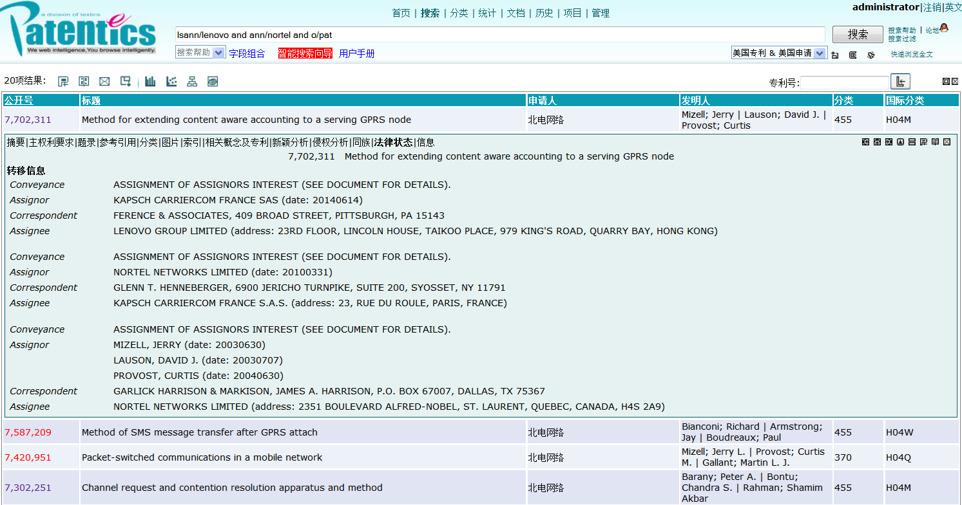
Nortel -> KAPSCH CARRIERCOM FRANCE S.A.S. -> LENOVO GROUP LIMITED

Nortel -> ROCKSTAR BIDCO, LP -> | APPLE INC.

Method for extending content aware accounting to a serving GPRS node

授权号: US7702311

优先权日: 2003/06/30 申请日: 2003/06/30 授权日: 2010/04/20

申请人: 北电网络 专利权人: 联想

发明人: Mizell; Jerry|Lauson; David J.|Provost; Curtis

摘要

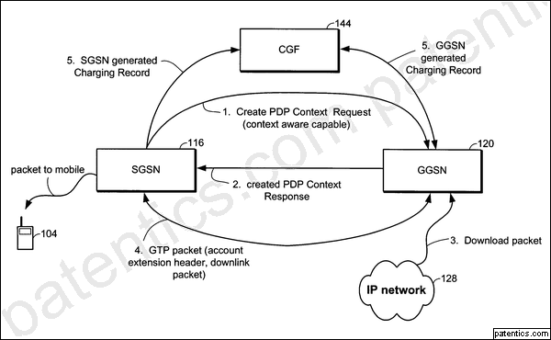A serving GPRS node (SGSN) is made content aware by passing content based rate information in the GPRS tunnel protocol (GTP) header. The SGSN uses the PDP context request to inform a GPRS support node (GGSN) that it is content aware and can process the content based rate information. In one embodiment, the rate information is passed in a GTP extension header. A new GTP header type tells the SGSN that rate information is present in the GTP header content field. In an alternate embodiment, the rate information is passed in a fourth octet of a four octet tunnel endpoint identifier (TEID).

主权项 专利度: 17 特征度: 32

A method for billing a mobile terminal in a general packet radio service (GPRS) network, comprising: determining a rate for a data packet based upon content; and generating a corresponding charging record relating a charge rate to a quantity of data packets transmitted at the charge rate, wherein the corresponding charging record is based upon a number of successfully delivered data packets of the quantity of data packets.

申请主权项 专利度: 22 特征度: 8

A method for billing a mobile terminal in a general packet radio service (GPRS) network, comprising: determining a rate for a data packet based upon content; and generating a corresponding charging record relating a charge rate to a quantity of data packets transmitted at the charge rate, wherein the corresponding charging record is based upon a number of successfully delivered data packets of the quantity of data packets.

引用/自引用/引用公司: 7/0/5

被引用/被自引用/被引用公司: 2/0/2

同族: 1

法律状态: Valid

Method of SMS message transfer after GPRS attach

授权号: US7587209

优先权日: 2002/12/30 申请日: 2002/12/30 授权日: 2009/09/08

申请人: 北电网络 专利权人: 联想

发明人: Bianconi; Richard|Armstrong; Jay|Boudreaux; Paul

摘要

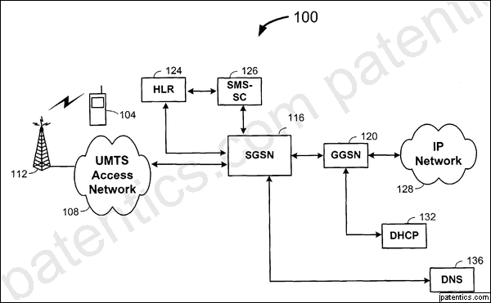A method in an SGSN of a GPRS/UMTS network for wireless communications including a mobile node, the SGSN, a GGSN, an HLR, an SMS-G and a SMS-SC includes introducing a delay after a mobile node has attached and is connected to allow the delivery of SMS messages before initiating tear down procedures to place the mobile node in a standby mode of operation by tearing down the signaling links between the mobile node and the SGSN. Generally, the inventive process performed by the SGSN includes receiving, from the mobile node, an initial UE (attach request) message to establish a signaling link, authenticating the mobile node to determine whether to allow it to attach to the network, accepting and completing the attach, informing the HLR that the mobile node is attached and delaying the tear down of the signaling links for a period sufficient to enable the SMS-SC to deliver any queued SMS messages.

主权项 专利度: 16 特征度: 18

A method in an SGSN of a GPRS/UMTS network for wireless communications including a mobile node, the SGSN, a GGSN, an HLR, an SMS-G and a SMS-SC, the method comprising: receiving, from the mobile node, an initial UE (attach request) message to establish a signaling link; authenticating the mobile node to determine whether to allow it to attach to the network; informing an HLR that the mobile node is attached; accepting and completing the attach; delaying the tear down of the attached signaling link to keep the mobile node in a connected mode of operation with signaling links present; receiving a short message service message from an SMS gateway (interworking function); delivering the short message service message to the mobile node; and tearing down the attached signaling link to place the mobile node in a standby mode of operation: wherein the step of delaying includes initiating a countdown timer; wherein the delaying step is terminated and the attached signaling link is torn down upon determining that there are no pending SMS messages for the mobile node.

申请主权项 专利度: 20 特征度: 23

A method in an SGSN of a GPRS/UMTS network for wireless communications including a mobile node, the SGSN, a GGSN, an HLR, an SMS-G and a SMS-SC, the method comprising: receiving, from the mobile node, an initial UE (attach request) message to establish a signaling link; authenticating the mobile node to determine whether to allow it to attach to the network; informing an HLR that the mobile node is attached; accepting and completing the attach; delaying the tear down of the attached signaling link to keep the mobile node in a connected mode of operation with signaling links present; receiving a short message service message from an SMS gateway (interworking function); delivering the short message service message to the mobile node; and tearing down the attached signaling link to place the mobile node in a standby mode of operation: wherein the step of delaying includes initiating a countdown timer; wherein the delaying step is terminated and the attached signaling link is torn down upon determining that there are no pending SMS messages for the mobile node.

引用/自引用/引用公司: 9/1/3

被引用/被自引用/被引用公司: 2/0/1

同族: 1

法律状态: Valid

Packet-switched communications in a mobile network

授权号: US7420951

优先权日: 1999/11/12 申请日: 2000/07/03 授权日: 2008/09/02

申请人: 北电网络 专利权人: 联想

发明人: Mizell; Jerry L.|Provost; Curtis M.|Gallant; Martin L. J.

摘要

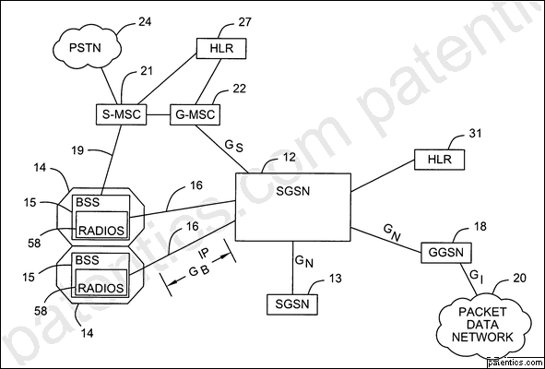A mobile communications system includes a system controller and cell sites having base station systems. The network between the system controller and the base station systems is a packet-switched network, such as an Internet Protocol (IP) network. In one embodiment, the mobile communications system is a General Packet Radio Service (GPRS) system. The system controller is a serving GPRS support node (SGSN), and the network between the SGSN and the base station systems includes a Gb network. In one arrangement, IP addressing is used to communicate messages between the base station systems and the SGSN.

主权项 专利度: 16 特征度: 23

A serving GPRS support node (SGSN) for use in a mobile communications network having a plurality of cell sites, comprising: a connectionless, packet-based protocol layer to communicate, over a Gb interface, packets with a connectionless, packet-based protocol layer of a base station system in a cell site; and a controller adapted to transmit and receive data through the connectionless, packet-based protocol layer of the SGSN over the Gb interface with the base station system according to a connectionless, packet-based protocol.

引用/自引用/引用公司: 46/1/16

被引用/被自引用/被引用公司: 7/0/5

同族: 1

法律状态: Valid
Channel request and contention resolution apparatus and method

授权号: US7302251

优先权日: 2000/10/06 申请日: 2001/08/30 授权日: 2007/11/27

申请人: 北电网络 专利权人: 联想

发明人: Barany; Peter A.|Bontu; Chandra S.|Rahman; Shamim Akbar

摘要

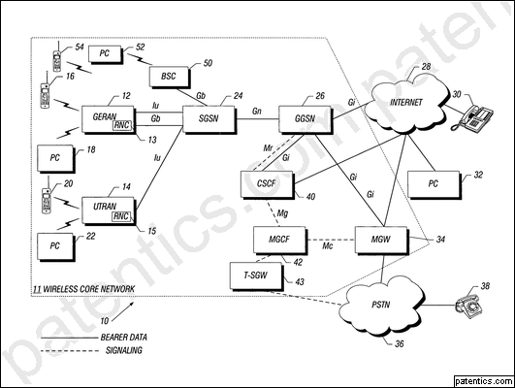A wireless network includes wireless access systems for communicating with mobile stations. At least one of the wireless access systems is capable of communicating with multiple types of mobile stations. One type of mobile station communicates according to the Enhanced General Packet Radio Service (EGPRS) protocol, while another type of mobile station communicates according to the GSM/EDGE Radio Access Network (GERAN) protocol. The wireless access system includes control logic to select one of plural types of protocol stacks to use for communications over an air link with the different types of mobile stations. In response to an indicator of a first type, the wireless access system selects a first protocol stack, and in response to an indicator of a second type, the wireless access system selects a second protocol stack.

主权项 专利度: 12 特征度: 22

A method of controlling communications in a wireless network comprising: receiving, in a wireless network controller, a Temporary Logical Link Identity (TLLI) structure in a message sent over an air link by a mobile station to establish a data transfer session in the wireless network; and selecting one of plural types of protocol stacks in the wireless network controller to use for communications over the air link between the wireless network controller and mobile station based on a value of the TLLI structure, wherein selecting one of plural types of protocol stacks comprises selecting from protocol stacks comprising a GERAN protocol stack.

申请主权项 专利度: 25 特征度: 10

A method of controlling communications in a wireless network comprising: receiving, in a wireless network controller, an indicator Temporary Logical Link Identity (TLLI) structure in a message sent over an air link by a mobile station to establish a data transfer session in the wireless network; and selecting one of plural types of protocol stacks in the wireless network controller to use for communications over anthe air link between the wireless network controller and mobile station based on the indicatora value of the TLLI structure, wherein selecting one of plural types of protocol stacks comprises selecting from protocol stacks comprising a GERAN protocol stack.

引用/自引用/引用公司: 14/0/6

被引用/被自引用/被引用公司: 2/0/2

同族: 5

法律状态: Valid

Method for sending modulated-signal blocks, sending station and data source for the implementation of the method

授权号: US7283501

优先权日: 2001/07/02 申请日: 2002/07/02 授权日: 2007/10/16

申请人: 北电网络 专利权人: 联想

发明人: Cayla; Ste|Eskicioglu; Suat

摘要

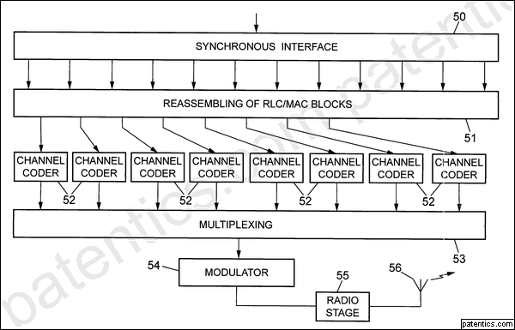The modulated-signal blocks are formed by a sending station from respective data blocks of variable size received from a data source on a time-division multiplexing synchronous link. They are then sent with a specified block rate on multiplexed physical channels. The synchronous link between the data source and the sending station supports dedicated channels respectively associated with the physical channels, each offering a specified transmission capacity determined over a sending period inverse to the block rate, and supplementary channels. A part at least of each data block intended for a physical channel is transmitted on the associated dedicated channel. When the size of the block exceeds the transmission capacity, another part is transmitted on at least one supplementary channel of the synchronous link, allocated dynamically to the physical channel.

主权项 专利度: 12 特征度: 9

A method for sending modulated-signal blocks on multiplexed physical channels, the method comprising: forming the modulated-signal blocks by a sending station from respective data blocks of variable size received from a data source on a time-division multiplexing synchronous link, and sending the modulated-signal blocks with a specified block rate on each physical channel, wherein the synchronous link between the data source and the sending station supports dedicated channels respectively associated with the said physical channels, each offering a specified transmission capacity over a sending period inverse to the block rate, and supplementary channels; transmitting a part at least of each data block from which is formed a modulated-signal block sent on a physical channel from the data source to the sending station on the dedicated channel associated with the said physical channel; and transmitting another part of the said data block, when the size of the said data block exceeds the said transmission capacity, on at least one supplementary channel of the synchronous link, allocated dynamically to the said physical channel, wherein, on each supplementary channel of the synchronous link allocated to a physical channel for a sending period, an address identifying the said physical channel is transmitted.

申请主权项 专利度: 14 特征度: 18

A method for sending modulated-signal blocks on multiplexed physical channels, wtherein method comprising: forming the modulated-signal blocks are formed by a sending station from respective data blocks of variable size received from a data source on a time-division multiplexing synchronous link, and are sentsending the modulated-signal blocks with a specified block rate on each physical channel, wherein the synchronous link between the data source and the sending station supports dedicated channels respectively associated with the said physical channels, each offering a specified transmission capacity over a sending period inverse to the block rate, and supplementary channels, and where; transmitting a part at least of each data block from which is formed a modulated-signal block sent on a physical channel is transmitted from the data source to the sending station on the dedicated channel associated with the said physical channel,; and transmitting another part of the said data block, when the size of the said data block exceeds the said transmission capacity, another part of the said data block is transmitted on at least one supplementary channel of the synchronous link, allocated dynamically to the said physical channel, wherein, on each supplementary channel of the synchronous link, allocated dynamically to a physical channel for a sending period, an address identifying the said physical channel is transmitted.

引用/自引用/引用公司: 2/0/1

被引用/被自引用/被引用公司: 1/0/1

同族: 7

法律状态: Valid

Data session service initialization for wireless devices

授权号: US7072961

申请日: 2001/12/31 授权日: 2006/07/04

申请人: 北电网络 专利权人: 联想

发明人: Maclean; Ian|Subramaniam; Gokul

摘要

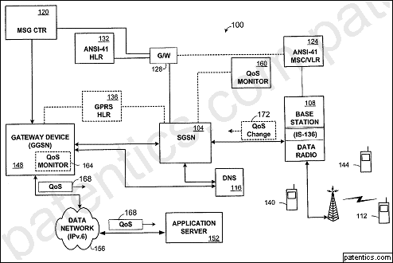A system and method of the present invention include a gateway device that serves as an interface between a high speed wireless data packet network and an application server placed within a wireline data packet network such as the Internet. The gateway device generates network performance indicators that reflect performance of the high speed wireless data packet network and transmits them to an application server. This enables the quality of service determinations to be made by the application server with at least some knowledge of the wireless network's ability to support the selected quality of service. In the described embodiment of the invention, the gateway devices are GPRS/UMTS gateway GPRS support nodes (GGSNs). The GGSNs generate network performance indicators.

主权项 专利度: 20 特征度: 16

A high-speed wireless data packet network, comprising: an application server for transmitting data to a mobile terminal by way of a wired data packet network and subsequently by way of a wireless communication link; and a gateway device providing an interface between the application server and network elements of the high speed wireless data packet network that form the wireless data packet network wherein a gateway general packet radio service (GPRS) service node (GGSN) is formed to pass network performance parameters relating to the wireless data packet network to the application server while a data session is being established to enable the application server to determine an appropriate quality of service (QoS) level of data transfer.

引用/自引用/引用公司: 6/0/2

被引用/被自引用/被引用公司: 16/0/15

法律状态: Valid

Disaster recovery for very large GSM/UMTS HLR databases

授权号: US7039402

申请日: 2003/08/05 授权日: 2006/05/02

申请人: 北电网络 专利权人: 联想

发明人: Gan; Hock|Sarkar; Pallab|Kohler; Darren

摘要

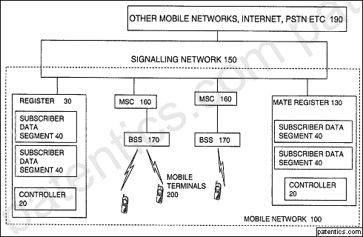An HLR register for maintaining data relating to mobile users of a network for use by the network, the register being arranged to be coupled to a mate register at a remote location for back up of the data, the register being divided into segments and arranged to carry out a partial handover to the mate register by handing over maintenance of data of one or some of the segments to the mate register temporarily. By allowing a partial handover rather than requiring a complete handover, the handover can be simpler and quicker. This can reduce the risk of loss of data or reduce an amount of down time and consequential losses of revenue. This is particularly important for larger registers. The handover can be triggered by a fault in the segment or for the purpose of planned maintenance for example. It can be triggered manually or automatically.

主权项 专利度: 14 特征度: 19

A location register for maintaining data relating to current location of users of a mobile telephone network for use by the mobile telephone network, the location register being arranged for coupling to a mate location register at a remote location for back up of the data, the location register comprising a controller which is arranged to divide the data into segments and to carry out a partial handover to the mate location register by handing over maintenance of data of one or some of the segments to the mate location register temporarily, wherein the handing over is triggered by a fault in the segments, and wherein the controller maintains a map of which users belong to which segment.

引用/自引用/引用公司: 17/4/8

被引用/被自引用/被引用公司: 7/0/5

法律状态: Valid

Communicating over one or more paths in an interface between a base station and a system controller

授权号: US7006478

优先权日: 2000/05/22 申请日: 2000/11/17 授权日: 2006/02/28

申请人: 北电网络 专利权人: 联想

发明人: Mizell; Jerry L.|Provost; Curtis M.

摘要

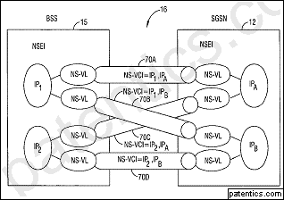A mobile communications network includes base stations and a system controller, such as a serving GPRS support node (SGSN) of a General Packet Radio Service network. An interface, such as a Gb interface, is provided between each base station and the system controller. A plurality of paths (e.g., Network Service virtual circuits) in the interface are identified, with each path defined by an address in the base station and an address in the system controller. One of the plurality of paths is associated for a given mobile station. Load sharing can be accomplished by employing either an implicit path negotiation or an explicit path negotiation.

主权项 专利度: 31 特征度: 11

A method of establishing communications between a base station and a system controller over a network, comprising: identifying a plurality of paths in the network, each path defined by an address in the base station and an address in the system controller; and selecting one of the plurality of paths to communicate data associated with a given mobile station, wherein selecting one of the plurality of paths comprises performing an implicit negotiation in which the path is defined by a source Internet Protocol (IP) address of a message communicated by the base station and by a source IP address of a message communicated by the system controller.

引用/自引用/引用公司: 40/1/15

被引用/被自引用/被引用公司: 9/0/7

同族: 1

法律状态: Valid
Allocating carrier frequencies for communicating beacon control signaling

授权号: US6907228

申请日: 2002/01/24 授权日: 2005/06/14

申请人: 北电网络 专利权人: 联想

发明人: Lohtia; Anit|Tang; Yuqiang|Tse; Paul Chan H.

摘要

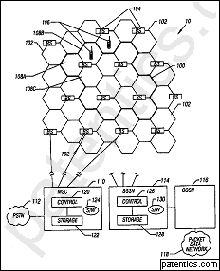A mobile communications network includes a plurality of cells and cell sectors in each cell. Carrier frequencies for carrying beacon control signaling, such as a broadcast control channel (BCCH), are assigned from the entire band of available carrier frequencies. The same carrier frequencies are assigned to carry traffic channels. This arrangement enables the use of one carrier frequency to communication beacon control signaling in one cell segment, while also allowing the use of the same one carrier frequency to communicate bearer traffic in another cell segment, thus affording substantial increases in network capacity that has heretofore not been possible in networks in the absence of significant infrastructure buildout or modification.

主权项 专利度: 25 特征度: 22

A method for use in a mobile communications network, comprising: defining a band of carrier frequencies for the mobile communications network; for a first cell segment, allocating one of the carrier frequencies in the band for communicating beacon control signaling; for another cell segment, allocating the one of the carrier frequencies to carry bearer traffic; allocating a first group of carrier frequencies to the first cell segment, and allocating a second, distinct group of carrier frequencies to a second cell segment that is different from the another cell segment, wherein the one carrier frequency for communicating beacon control signaling is part of the plurality first group of carrier frequencies allocated to the first cell segment.

引用/自引用/引用公司: 7/0/5

被引用/被自引用/被引用公司: 8/0/6

法律状态: Valid

Mobile communication system using loss cables as transmission elements

授权号: US6876854

优先权日: 1999/11/26 申请日: 2000/11/27 授权日: 2005/04/05

申请人: 北电网络 专利权人: 联想

发明人: Ferray; Jean-Pierre

摘要

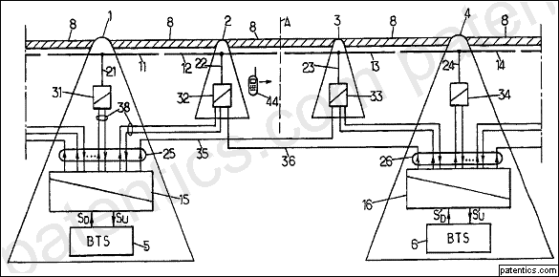Runs of loss cable are disposed in succession along a zone of radio coverage and coupled with feeder means from base stations of a cellular mobile communication network. The feeder means apply first radio frequency signals from a first base station to a first cable run and second radio frequency signals from a second base station to a second cable run, adjacent to the first run. They also apply at least part of the second radio frequency signals to the first cable run, preferably attenuated relative to the first radio frequency signals as applied to the first cable run, creating a zone of partial coverage between adjacent cells in order to facilitate operation of an automatic cell changeover during calls.

主权项 专利度: 8 特征度: 40

Mobile communication system, comprising runs of loss cable disposed in succession along a zone of radio coverage and feeder means for feeding the cable runs from base stations of at least one cellular mobile communication network, wherein the feeder means comprise: means for applying first radio frequency signals from a first base station of the cellular mobile communication network to a first cable run, said first radio frequency signals including a first beacon signal specific to a cell serviced by said first base station; means for applying second radio frequency signals from a second base station of the cellular mobile communication network to a second cable run which is adjacent to the first run, said second radio frequency signals including a second beacon signal specific to a cell serviced by said second base station; and, means for applying to the first cable run together with said first radio frequency signals at least part of the second radio frequency signals including said second beacon signal.

引用/自引用/引用公司: 4/0/3

被引用/被自引用/被引用公司: 2/0/2

同族: 8

法律状态: Valid

Device for allocating resources in a radiocommunication network

授权号: US6636736

优先权日: 1997/09/12 申请日: 2000/07/13 授权日: 2003/10/21

申请人: 北电网络 专利权人: 联想

发明人: Billon; Thierry

摘要

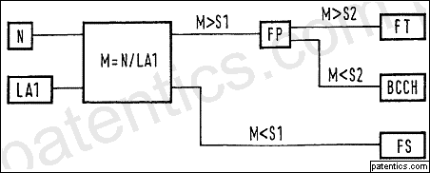A system for allocating a resource to a terminal in a cellular mobile radio network in which each cell of the network is identified by a primary color and a secondary color which correspond to transmission frequencies allocated to it, namely and respectively a set of primary frequencies (FP) and a set of secondary frequencies (FS) whose rate of re-use is higher than that of said primary frequencies (FP), and the terminal is connected to a local cell (A1). The system knows a potential level of interference (N) received by the terminal and allocates said resource to said terminal on a primary frequency (FP) or on a secondary frequency (FS) according to whether said potential level of interference (N) is respectively above or below a first distribution threshold (S1).

主权项 专利度: 9 特征度: 4

A system for allocating a resource to a terminal in a cellular mobile radio network in which each cell of the network is identified by a primary color and a secondary color which correspond to transmission frequencies allocated to it, namely and respectively a set of primary frequencies (FP) and a set of secondary frequencies (FS) whose rate of re-use is higher than that of said primary frequencies (FP), and the terminal is connected to a local cell (A1), in which the system knows a potential level of interference (N) received by the terminal and allocates said resourse to said terminal on a primary frequency (FP) or on a secondary frequency (FS) according to whether said potential level of interference (N) is respectively above or below a first distribution threshold (S1), and in which the system knows a cumulative probability (P (N>S)) of said distribution threshold (S1) by comparing said cumulative probability with the ratio of the number of resources of said set of primary frequencies to the total number of resources.

引用/自引用/引用公司: 5/0/5

被引用/被自引用/被引用公司: 9/0/6

同族: 6

法律状态: Valid

Distributed flow control system and method for GPRS networks based on leaky buckets

授权号: US6578082

优先权日: 1999/08/02 申请日: 1999/08/02 授权日: 2003/06/10

申请人: 北电网络 专利权人: 联想

发明人: Ho; Joseph S.|Zhu; Yixin|Hanson; Mark Eric

摘要

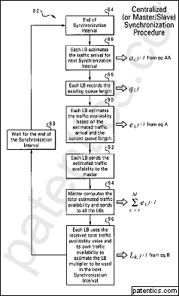A distributed flow control system and method for GPRS networks to control and regulate data flow between multiple sources and a single destination within a GPRS network. The present system and method ensures the departing traffic from all of the sources conforms to the peak and average rate requirements that have been set forth by the BSS/PCU. A leaky bucket flow control mechanism is used at each respective one of the multiple sources for controlling flow of data from each respective source to the single destination. A maximum bucket size of a leaky bucket and a bucket leak rate are defined for each leaky bucket flow control mechanism. A multiplier (L) is estimated and determined for each respective source based on recent data arrival behaviors of the multiple sources. When a frame of the data is sent from the respective source to the single destination, a number of bytes equal to the size of the transmitted frame times the multiplier L is added to the leaky bucket.

主权项 专利度: 14 特征度: 28

A distributed flow control method for controlling flow of data between multiple sources and a single destination within a GPRS network, said method comprising the steps of: using a leaky bucket flow control mechanism having a leaky bucket with a maximum bucket size and a bucket leak rate at each respective one of the multiple sources for controlling the flow of the data from the multiple sources to the single destination, estimating a traffic availability for the leaky bucket at each of the multiple sources for a next time interval based on arrival and queuing behaviors of each of the multiple sources, determining a total traffic availability for the next time interval by collecting and totaling a traffic availability from each of the multiple sources, allowing an additional data frame to be sent to the single destination from those of the multiple sources at which the leaky bucket will not overflow based on the estimated traffic availability after sending the additional data frame in the next time interval, prohibiting an additional data frame from being sent to the single destination from those of the multiple sources at which the leaky bucket will overflow based on the estimated traffic availability after sending the additional data frame in the next time interval, and at each of those multiple sources sending an additional data frame, adding a number of bytes of data to the leaky bucket equal to a size of the additional data frame multiplied by a respective leaky bucket multiplier greater than 1, wherein the respective leaky bucket multiplier of each source is calculated based upon said total traffic availability for the next time interval.

引用/自引用/引用公司: 6/0/6

被引用/被自引用/被引用公司: 24/0/15

同族: 3

法律状态: Valid

Method and system for reducing call setup processing cost by determining when to forward calls to detached subscribers

授权号: US6477375

申请日: 1999/04/16 授权日: 2002/11/05

申请人: 北电网络 专利权人: 联想

发明人: Ho; Joseph S. M.|Maturino; Hector

摘要

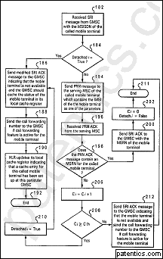A method and system for improving overall system capacity in GSM networks by reducing the number of visitor location register queries is disclosed. The method and system determines if subsequent calls for a mobile terminal which has been detached by its subscriber from the GSM network should require querying of its visiting mobile switching center and HLR based on the call arrival characteristics of the subscriber. A quot;call-arrival-after detachquot; counter is created at the home location register and visitor location register for tracking the number of incoming calls that occur during the interval when the subscriber has detached. The value of this counter is compared for every incoming call to a threshold level value for determining if the call is to be forwarded. The threshold level value is determined on the past call arrival characteristics of the subscriber. The method and system of the present invention makes it unnecessary to query the VLR when a land-to-mobile call arrives for a subscriber and the subscriber has detached from the network thereby increasing network capacity while reducing processing load.

主权项 专利度: 18 特征度: 8

A method for reducing call setup costs for mobile communications networks when processing calls for mobile terminals of one or more subscribers at a home location register received from a gateway mobile switching center, comprising the steps of: determining at a home location register if a mobile terminal for a subscriber has detached from a visiting mobile switching center, including determining at said home location register if a condition Detachi is true; and responsive to said determination that said mobile terminal has not detached, further determining if subsequent calls for said mobile terminal should be forwarded to said visiting mobile switching center by said home location register based on call arrival characteristics for said subscriber, including caching said determining information at said gateway mobile switching center for use by said gateway mobile switching center in determining to forward incoming calls for said mobile terminal to said home location register.

引用/自引用/引用公司: 6/0/4

被引用/被自引用/被引用公司: 6/1/6

法律状态: Valid

Method and apparatus for enhanced call setup

授权号: US6314292

优先权日: 1997/08/15 申请日: 1997/08/15 授权日: 2001/11/06

申请人: 北电网络 专利权人: 联想

发明人: Ho; Joseph S. M.|Xu; Jim

摘要

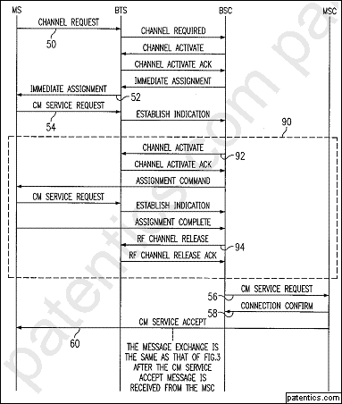A method is illustrated for reducing the call setup time of high priority calls such as voice or high speed user generated data without unduly wasting RF frequency resources on non priority calls such as short message calls. This is accomplished by ascertaining the call priority at the base station controller (BSC) level in a GSM system soon after call initiation and immediately changing the channel assignment for use by the remaining signalling type messages to a different operational speed where appropriate. The concept is further extended by supplying the call priority data to a called party's BSC such that all signalling messages after initial contact can be at the operational speed appropriate to the priority of the call.

主权项 专利度: 15 特征度: 17

A method of assigning one of two different speed signaling channel types, f1 and f2, in response to signaling channel requests made prior to a communication and associated data pertaining to communication priority in a cellular communication network having a plurality of possible channels of each of types f1 and f2, the method comprising the steps, performed during call setup, of:

initially assigning a signaling channel type f1 in response to a channel request by a mobile station;

reading a service request message to make a determination of the service type requested;

changing during call setup to signaling channel type f2 in response to a determination that the service type requested is a signaling channel type f2; and

completing call setup using the signaling channel type requested in the service request message.

引用/自引用/引用公司: 2/0/2

被引用/被自引用/被引用公司: 15/0/7

同族: 7

法律状态: Valid

Overload control for an integrated MSC/HLR switch

授权号: US6151499

优先权日: 1995/07/31 申请日: 1998/07/24 授权日: 2000/11/21

申请人: 北电网络 专利权人: 联想

发明人: Vudali; Madhusudham|Racz; Steven W.|Bird; Stephen|Rehman; Imran|Basu; Kalyan

摘要

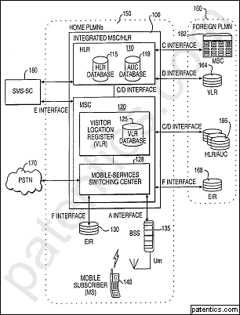An integrated MSC/HLR switch accommodates overloads by throttling peripherals during MSC overload conditions, and halting TCAP messages and throttling peripherals during HLR overload conditions.

主权项 专利度: 19 特征度: 15

An integrated Mobile Switching Center (MSC).backslash.Home Location Register (HLR) switch receiving MSC and HLR messages, the switch comprising:

HLR overload detect means for generating an HLR overload condition signal in response to the detection of an HLR overload condition;

MSC overload detect means for generating an MSC overload condition signal in response to the detection of an MSC overload condition; and

throttling means, responsive to the HLR overload condition signal and MSC overload condition signal, for signaling a need for reducing the number of MSC messages received by the switch.

引用/自引用/引用公司: 9/3/4

被引用/被自引用/被引用公司: 6/1/5

同族: 1

法律状态: Valid

Cellular communications system

授权号: US6138017

优先权日: 1997/12/08 申请日: 1997/12/08 授权日: 2000/10/24

申请人: 北电网络 专利权人: 联想

发明人: Price; David|Maginley; Ronald James|Kaura; Ricky

摘要

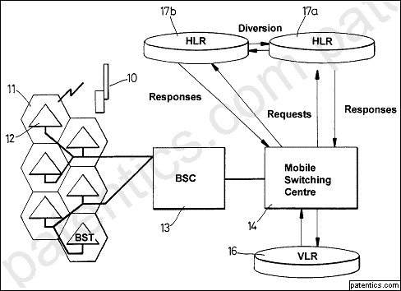A mobile communications system incorporates a plurality of home location registers on which subscriber data is stored such that each subscriber is allocated to a selected one of the registers for voice and/or data calls. Request messages for subscriber data can be routed to any home location register which responds to that request when the data for the respective subscriber is stored on that home location register. If the data for the respective subscriber is not stored on that home location register, the message is provided with an indicator component and is rerouted to another home location register for a further processing attempt. The number of times a message is rerouted is limited to prevent perpetual circulation of messages relating to unknown subscribers.

主权项 专利度: 7 特征度: 13

A method of routing subscriber information request messages in a

cellular communications network incorporating a plurality of home location registers each serving a common service region and on which registers subscriber data for subscribers each having a unique identity and allocated to that common service region is stored such that each subscriber is allocated only to a selected one of said registers, the method including routing for a subscriber a request message incorporating the subscriber identity to one of said home location registers irrespective of whether or not the subscriber details corresponding to that subscriber are stored on that one home location register, at said one home location register, processing the request message to a stage at which the subscriber identity contained in the message is verified, determining whether the subscriber details are stored on said one home location register, completing processing of the request message at that said home location register if the corresponding subscriber details are determined to be stored on said one home location register, and, when the subscriber details are not stored on said one home location register, adding an indicator component to the request message and diverting the request message to one or more other home location registers whereby to attempt processing of the request message at one of said other home location registers, and wherein the number of diversions to which said request message is subjected is limited to a predetermined number determined by said indicator.

引用/自引用/引用公司: 11/1/5

被引用/被自引用/被引用公司: 26/1/10

同族: 8

法律状态: Valid

Distributing location tracking functionality in wireless telephone systems

授权号: US6138016

申请日: 1996/12/04 授权日: 2000/10/24

申请人: 北电网络 专利权人: 联想

发明人: Kulkarni; Jayant A.|Dawkins; Spencer|Hall; Michael

摘要

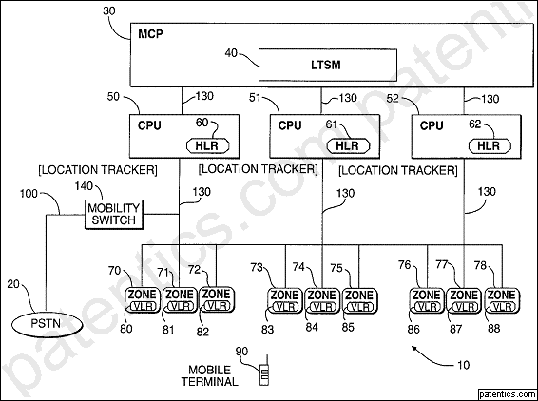There is disclosed a wireless communication system, including a distributed HLR, for tracking the location of mobile terminals moving between zones. There is also disclosed a method for distributing and managing the load created by the HLR functionality among a number of separate processing machines. The method permits dynamic load balancing among the HLRs to more evenly distribute the load.

主权项 专利度: 9 特征度: 8

A wireless communication system, including a distributed home location register, for tracking the location of mobile terminals, comprising:

a Mobility Control Point (MCP) mechanism for controlling communications in a plurality of geographically spaced zones and providing storage capabilities for service information relating to mobile terminals; a plurality of Central Processing Units (CPUs) associated with each MCP, each CPU including a corresponding Home Location Register (HLR), for storing enabled service information of a subset of mobile terminals serviced by the plurality of zones;

a plurality of Visitor Location Registers (VLRs), associated with each CPU and corresponding HLR, for temporarily storing mobile terminal data and connected to the associated CPU for communicating with the plurality of CPUs and corresponding HLRs;

means for tracking the location of the mobile terminals from one zone to another; and

a Location Tracking Service Manager (LTSM) configured to maintain proper load distribution throughout the system, wherein the LTSM includes:

means for dynamically partitioning a plurality of mobile terminal identifiers used for identifying associated service information into blocks;

means for storing a partitioning of mobile terminal identifiers into a memory map; and

means for transmitting the memory map.

引用/自引用/引用公司: 21/1/10

被引用/被自引用/被引用公司: 47/0/16

法律状态: Valid

Frequency assignment in wireless networks

授权号: US6023459

优先权日: 1996/12/04 申请日: 1996/12/04 授权日: 2000/02/08

申请人: 北电网络 专利权人: 联想

发明人: Clark; Timothy Ian James|Smith; George David

摘要

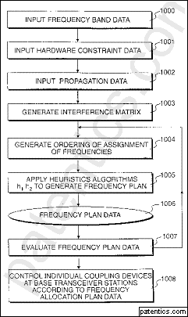The disclosure relates to wireless networks, and particularly a method and apparatus for assigning carrier frequencies to base station antenna sites. Base stations are represented as a matrix of interconnected nodes and links, the nodes representing carrier frequency sites and the links being dimensioned in accordance with disallowed frequency slots. A first algorithm is used to assign carrier frequencies to the carrier frequency sites in a non-interfering manner resulting in a partial frequency assignment plan. A second algorithm assigns carrier frequencies to the remaining vacant carrier sites in a manner which seeks to minimise the amount of interference. The order in which the carrier sites are assigned carrier frequencies is determined by either a random ordering, an order generated by simulated annealing, or an ordering generated by a genetic algorithm. A quality measure is generated from the resultant frequency plan and is used to modify the order in which the frequencies are assigned to carrier site nodes in subsequent iterations.

主权项 专利度: 17 特征度: 12

A method for assigning a set of communications frequencies to a plurality of network elements, each operating at least one frequency, the method comprising the steps of:

representing each said network element as a corresponding respective set of at least one frequency site node;

linking said plurality of frequency site nodes together by a plurality of dimensioned links, each said dimensioned link representing a constraint on the assignment of a communications frequency to at least one said node;

determining at least one order in which to assign said plurality of communications frequencies to said plurality of nodes;

for each node of the plurality, where possible assigning a frequency which does not interfere with frequencies assigned to other said nodes; and

for each node for which a non interfering frequency cannot be assigned, assigning to said node a frequency which causes a minimum interference with frequencies assigned to other said nodes,

wherein during said step of assigning a non-interfering frequency said nodes are selected in a first order and said frequencies are assigned to said nodes taken in said first order, and during said step of assigning a minimally interfering frequency, said nodes are selected in a second order and said frequencies are assigned to said nodes taken in said second order.

引用/自引用/引用公司: 13/1/10

被引用/被自引用/被引用公司: 35/1/23

同族: 4

法律状态: Valid

Overload control for an integrated MSC/HLR switch

授权号: US5867787

优先权日: 1995/07/31 申请日: 1995/07/31 授权日: 1999/02/02

申请人: 北电网络 专利权人: 联想

发明人: Vudali; Madhusudham|Racz; Steven W.|Bird; Stephen|Rehman; Imran|Basu; Kalyan

摘要

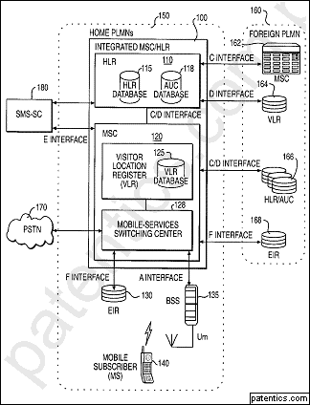An integrated MSC/HLR switch accommodates overloads by throttling peripherals during MSC overload conditions, and halting TCAP messages and throttling peripherals during HLR overload conditions.

主权项 专利度: 3 特征度: 19

A system for countering overload conditions in an integrated Mobile Switching Center (MSC).backslash.Home Location Register (HLR) switch receiving MSC and HLR messages, the system comprising:

a CPU with an HLR portion and an MSC portion;

the HLR portion including

database means for storing HLR configuration information,

HLR overload detect means for generating an HLR overload condition signal in response to an HLR overload condition;

the MSC portion including

means for routing MSC messages,

MSC overload detect means for detecting the presence of an MSC overload condition and for generating an MSC overload condition signal in response to the MSC overload condition, and

throttling means, responsive to the HLR overload condition signal and the MSC overload condition signal, for signaling the need for reducing the number of MSC messages received by the switch; and

peripheral devices, coupled to the CPU, said peripheral devices including means for limiting the messages sent to the CPU in response to the throttling means.

引用/自引用/引用公司: 10/4/4

被引用/被自引用/被引用公司: 20/1/14

同族: 1

法律状态: Valid

Query processing in a mobile communications system home location register

授权号: US5537594

优先权日: 1992/08/19 申请日: 1993/08/19 授权日: 1996/07/16

申请人: 北电网络 专利权人: 联想

发明人: Shannon; John P.|Prokopenko; John P.|Beaudry; Michelle A.

摘要

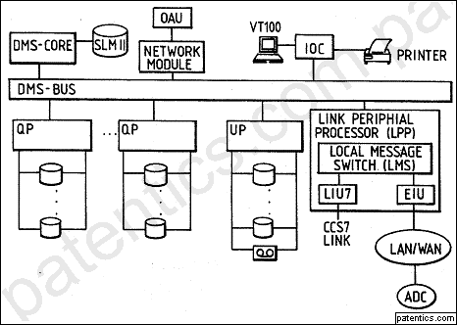A communications system query processing element, for example a home location register for a mobile communications system, includes a plurality of application processors. First data such as permanent data relating to a plurality of mobile subscribers (subscription information etc.) is available at all application processors, whereas second data such as temporary data relating to the plurality of subscription is partitioned between the application processors. Queries are allocated via a transaction bus to an available application processor. If it is not the correct one for the subscriber originating the query, it is redirected via the transaction bus. This arrangement permits a linear growth in terms of database to be achieved with increasing numbers of subscribers by the addition of application processors as necessary and in a manner not involving a processing bottleneck.

主权项 专利度: 5 特征度: 10

A home location register (HLR) for a mobile communications system and adapted to provide subscriber information in response to received requests, the register comprising a plurality of query processors, data storage means one associated with each said query processor, an update processor for updating data stored in said storage means, a peripheral processor incorporating a local message switch and having means for receiving requests for subscriber transactions and for relaying each request via the switch to a said query processor, a transaction bus via which the query processors and the peripheral processor can communicate and via which said requests are routed, wherein each said query processor is associated with a respective group of system subscribers, wherein a set of data is associated with each said subscriber, said data comprising permanent data and temporary data, wherein each said data storage means comprises a first store containing the permanent data relating to all subscribers and a second store containing the temporary data relating to the group of subscribers associated with the query processor corresponding to that data storage means, wherein said received requests are allocated each to an available query processor on an essentially random basis, and wherein each said query processor has means for processing requests relating to subscribers in the group associated with that query processor and for forwarding requests relating to subscribers not in that group each to the respective query processor whose group contains the subscriber.

引用/自引用/引用公司: 3/0/2

被引用/被自引用/被引用公司: 23/1/10

同族: 7

法律状态: Invalid

主权项修订统计

总计20篇;

无对比16篇;

对比4篇;

主权项被修订4篇;

主权项被插入17处;
主权项被删除11处;
主权项保留26处;

主权项没有修订0篇

